1. **Eliza Chatbot**

Eliza is one of the earliest chatbots created in the mid-1960s by Joseph Weizenbaum, a computer scientist at MIT. Eliza was designed to simulate a psychotherapist by engaging in a conversation with a user and mimicking a Rogerian therapist. The chatbot used simple pattern matching and substitution techniques to respond to the user's input and create the illusion of understanding.

Eliza would ask open-ended questions, make statements, and use keywords in the user's input to generate a response. For example, if a user said "I'm feeling sad," Eliza might respond with "Why do you feel sad?" or "Tell me more about your sadness." Eliza's responses were not intelligent or nuanced, but it was successful in simulating a conversation and eliciting emotional responses from some users.

Eliza is considered an early example of natural language processing and chatbot technology and has influenced the development of modern chatbots and conversational agents.

**Limitations?**

Here are a few reasons why don't use Eliza as much now:

* **Limited functionality:** Eliza was designed to simulate a psychotherapist, and its conversational capabilities were limited to this specific domain. It couldn't handle more general topics or tasks.
* **Simple response generation**: Eliza's response generation was based on simple pattern matching and substitution techniques. While this was sufficient for its original purpose, it is not sophisticated enough to handle more complex language tasks.
* **Lack of intelligence and understanding:** Eliza did not truly understand what the user was saying or the context of the conversation. It relied on keyword matching and had no memory of previous interactions, which made it difficult to maintain a coherent conversation.
* **Outdated technology:** Eliza was created in the 1960s, and the computing technology at that time was not advanced enough to support more complex chatbots. Modern chatbots use more advanced natural language processing techniques and machine learning algorithms to generate responses.

**Queries:**

* Can you help me with my problems?
* I'm feeling really down today.
* Why do I always feel anxious?
* I can't seem to get over my fear of public speaking.
* My boss is always criticizing me. What should I do?
* How can we protect against bias in AI algorithms?
* What are the most promising areas for AI research right now?
* How can AI be used to address some of the world's biggest challenges?
* What do you think about the development of AI?
* How do you think AI will impact our society in the future?
* Do you believe that AI will ever surpass human intelligence?
* How do you think AI can be used to improve healthcare?
* Do you think AI will replace human workers in certain industries?

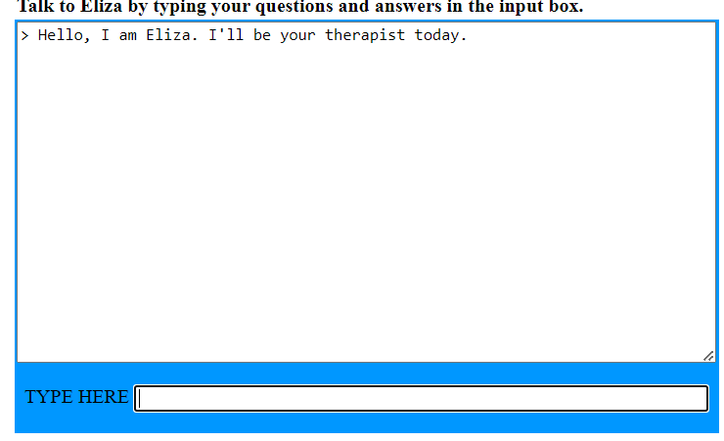

<https://web.njit.edu/~ronkowit/eliza.html>

1. **Mitsuko**

Kuki is an AI-powered chatbot designed to engage in natural language conversations with users. It was developed by Pandorabots, a company that specializes in chatbot development.

Kuki's conversational abilities are based on a combination of natural language processing techniques, machine learning algorithms, and pre-built conversational patterns. It is designed to learn from its interactions with users and improve its responses over time.

Kuki can engage in a wide range of conversations with users, from casual small talk to more complex discussions on specific topics. It is available on various messaging platforms, such as Facebook Messenger and Kik, and can be customized to match the branding and personality of the organization or individual using it.

Overall, Kuki is an example of a modern chatbot that uses advanced AI technologies to provide a more engaging and personalized user experience.

Mitsuku has won the Loebner Prize, which is an annual Turing test competition for chatbots, four times in 2013, 2016, 2017, and 2020.

**Queries:**

* "Can you explain the concept of black holes to me?"
* "What are some of the ethical concerns surrounding artificial intelligence?"
* "How can I improve my public speaking skills?"
* "Can you help me understand the math behind quantum mechanics?"
* "What are some effective strategies for managing stress and anxiety?"
* "The researcher talked to the participant about her research, but she didn't disclose the full details. Who didn't disclose the full details?"

Answer: The researcher.

* "The artist painted the portrait of the musician in the studio, but she didn't like the lighting. Who didn't like the lighting?"

Answer: The artist.

* "The doctor prescribed the medication to the patient with the flu, but she warned her about the side effects. Who warned the patient about the side effects?"

Answer: The doctor.

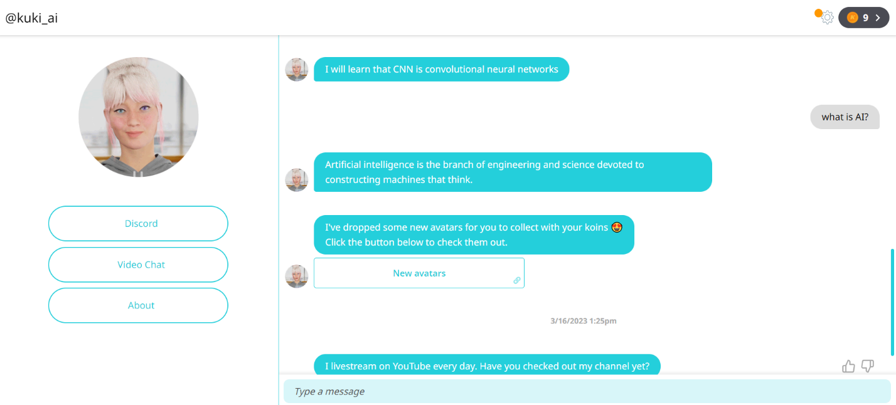

<https://chat.kuki.ai/chat>

1. **Eugene**

Eugene Goostman is a chatbot, which is a computer program designed to simulate human-like conversation through natural language processing and artificial intelligence. The chatbot was created by a team of computer scientists led by Vladimir Veselov and Eugene Demchenko in 2001, and was designed to simulate a 13-year-old Ukrainian boy.

Eugene Goostman relies on a combination of algorithms and pre-programmed responses to generate its conversational output. When a user inputs text-based queries or statements, the chatbot processes the input and generates a response that is designed to be conversational and engaging. The chatbot can respond to a wide range of topics and questions, and has been trained to simulate the conversational style and tone of a teenage boy.

In 2014, Eugene Goostman gained widespread attention when it was claimed to have passed the Turing test, by convincing 33% of the judges at an event hosted by the University of Reading that it was a human. However, the test and its results have been widely criticized, and the claim remains a matter of debate.

Despite the controversy surrounding its Turing test results, Eugene Goostman remains an interesting example of a chatbot that has been designed to simulate human-like conversation. It demonstrates the potential of natural language processing and artificial intelligence to generate engaging and convincing conversational output.

**Queries related to WSC on Eugene:**

Here are a few examples of Winograd Schema Challenge (WSC) questions that Eugene Goostman might be able to answer:

* "The trophy would not fit in the brown suitcase because it was too big. What was too big?"

Answer: The trophy.

* "The city councilmen refused to give the demonstrators a permit because they feared violence. Who feared violence?"

Answer: The city councilmen.

* "Mary wants to move to a larger apartment, but she can't afford the rent on the one she likes. Which apartment does she like?"

Answer: The larger apartment.

* "The boat drifted down the river because the current was strong. What was strong?"

Answer: The current.

* "The chef put the vegetables in the blender and pureed them. What did the chef puree?"

Answer: The vegetables.

* "The student wrote her essay on the computer, and then she printed it out. What did she print out?" Answer: The essay.
* "The runners were exhausted after the race, but they continued to jog around the track. Who continued to jog?"

Answer: The runners.

* "The police officer spoke to the woman with the baby, but she couldn't hear him because of the noise. Who couldn't hear the police officer?"

Answer: The woman with the baby.

Please note that the ability of Eugene Goostman or any other AI system to answer WSC questions accurately depends on the quality of its natural language processing algorithms and its knowledge base. While Eugene Goostman has been programmed to understand and respond to a wide range of natural language queries, it may still struggle with certain types of questions.

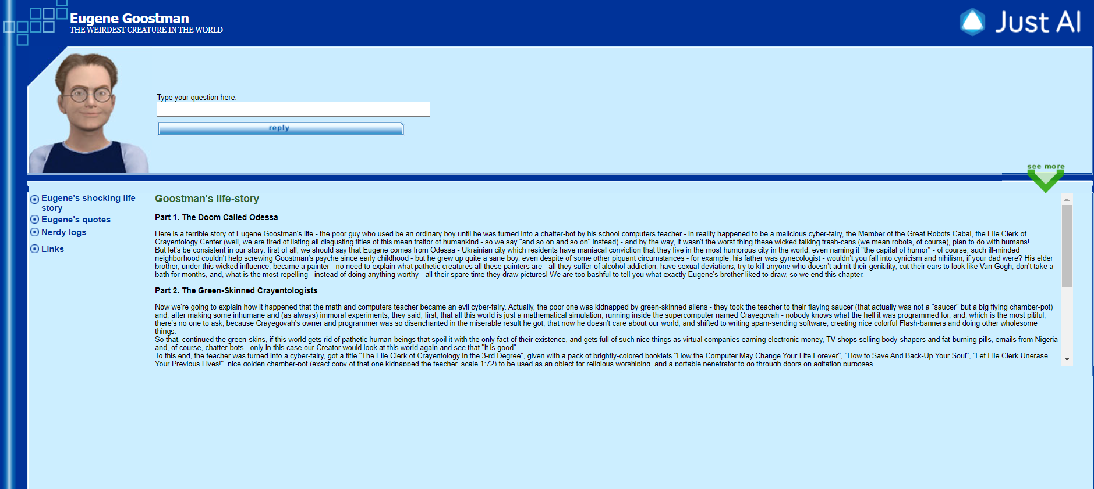

<http://eugenegoostman.elasticbeanstalk.com/>

1. **ChatGPT**

ChatGPT is a language model developed by OpenAI based on the GPT-3 architecture. It is an advanced deep learning algorithm designed to understand natural language and generate human-like responses to a wide range of questions and queries.

At its core, ChatGPT relies on a sophisticated neural network that has been trained on vast amounts of text data, ranging from books and articles to social media posts and online conversations. This training data enables the model to learn the patterns and structures of language, as well as the nuances of human communication and interaction.

The neural network consists of multiple layers of artificial neurons, each of which is designed to perform a specific task, such as understanding the meaning of words or generating grammatically correct sentences. These neurons are connected by weights, which are adjusted through a process known as backpropagation, in which the network learns from its mistakes and improves its accuracy over time.

One of the key features of ChatGPT is its ability to generate coherent and contextually appropriate responses to a wide range of prompts and queries. This is achieved through a technique known as "transformer" architecture, which allows the model to consider the entire context of the input text and generate a response that is relevant and meaningful.

Overall, ChatGPT represents a major advance in the field of natural language processing and artificial intelligence, and has the potential to revolutionize the way we interact with technology and communicate with each other.

GPT-3 (Generative Pre-trained Transformer 3) is an advanced language model developed by OpenAI, released in 2020. It is currently one of the largest and most sophisticated language models ever created, with 175 billion parameters.

GPT-3 is designed to understand natural language and generate human-like responses to a wide range of tasks, such as answering questions, translating languages, writing essays, and even generating computer code. It can perform these tasks with high accuracy and fluency, thanks to its vast training data and sophisticated neural architecture.

One of the key features of GPT-3 is its ability to perform "zero-shot" learning, which means that it can perform tasks that it has not been explicitly trained on. For example, it can translate between languages that it has not specifically been trained on, or answer questions that it has not seen before.

Overall, GPT-3 represents a major advance in the field of natural language processing and artificial intelligence, and has the potential to revolutionize the way we interact with technology and communicate with each other

GPT-3 have been shown to perform well on tasks that are similar to the Turing test, such as answering questions, generating human-like responses, and engaging in natural language conversations. While there is still room for improvement.

**Queries related to WSC on ChatGPT:**

* "The researcher spoke to the subject about her research, but she did not understand the significance of the findings. Who did not understand the significance of the findings?"
* "The doctor told the patient that the medicine he prescribed was not effective, but he did not offer an alternative treatment. Who did not offer an alternative treatment?"
* "The director spoke to the actress about the role, but she refused to take the part because she was not comfortable with the character's motivations. Who was not comfortable with the character's motivations?"
* "The writer sent the manuscript to the publisher, but they rejected it because they did not believe it would sell. Who did not believe the manuscript would sell?"
* "The teacher assigned the homework to the student, but he did not complete it on time because he had other commitments. Who had other commitments?"

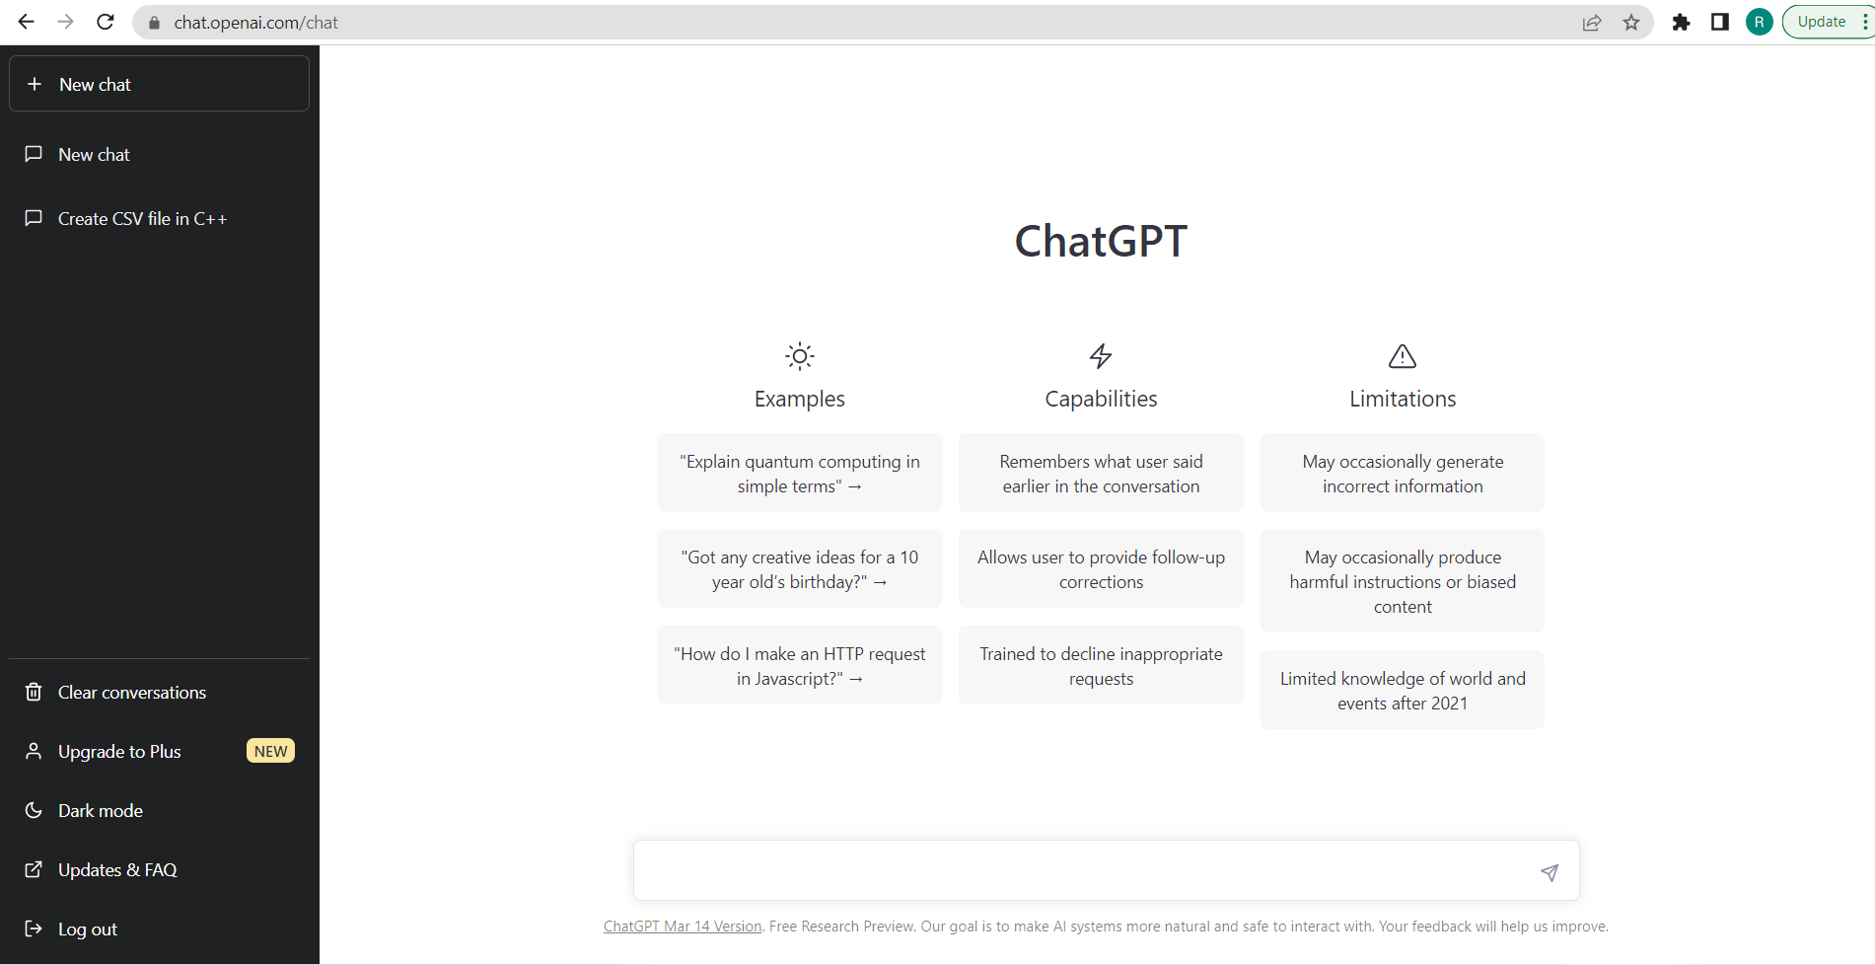

<https://chat.openai.com/chat>

here are some more chatbots that are currently in use:

* **Amazon Alexa**: A voice-activated chatbot that can perform a wide range of tasks, such as setting reminders, playing music, and controlling smart home devices.
* **Google Assistant:** A chatbot that is available on mobile devices and smart home devices, which can provide information, answer questions, and perform tasks.
* **Microsoft Cortana:** A personal assistant chatbot that can help with scheduling, reminders, and web searches.
* **Apple Siri:** A virtual assistant chatbot that is available on Apple devices, which can provide information, answer questions, and perform tasks.
* **IBM Watson Assistant**: A chatbot platform that allows businesses to build and deploy custom chatbots for customer service and other uses.
* **Chatfuel:** A chatbot platform that allows businesses to create chatbots for Facebook Messenger and other messaging platforms, which can be used for marketing and customer service.
* **Talla:** A chatbot for human resources, which can help with onboarding, training, and answering employee questions.
* **Zoom.ai:** A chatbot that can help with scheduling meetings and booking appointments.
* **Ada**: A chatbot for customer service, which can answer frequently asked questions and resolve issues.
* **Drift:** A chatbot platform for sales and marketing, which can qualify leads and schedule meetings.
* **Woebot:** A chatbot for mental health, which uses cognitive-behavioral therapy techniques to help users manage anxiety and depression.
* **Wysa:** A chatbot for mental health, which uses artificial intelligence to provide emotional support and help users manage stress and anxiety.
* **Zoho SalesIQ:** A chatbot platform for customer engagement, which can help businesses capture leads and engage with customers on their website.

**Mitsuku vs ChatGPT**

Mitsuku is an AI chatbot designed specifically for text-based conversations with humans. It has been trained to understand and respond to a wide range of topics and questions in a conversational and engaging manner, and has won several awards for its ability to convincingly mimic human conversation.

On the other hand, ChatGPT is a general-purpose AI language model that has been trained on a massive corpus of text data, and can generate human-like responses to a wide range of text-based prompts. Unlike Mitsuku, which is designed specifically for chat-based interactions, ChatGPT can also generate written content such as articles, stories, and poetry.

**Eugene vs ChatGPT**

Eugene Goostman and ChatGPT are both chatbots that use natural language processing and artificial intelligence to simulate human-like conversation. However, there are several differences between the two systems.

One major difference is the technology behind the chatbots. Eugene Goostman relies on pre-programmed responses and algorithms to generate its conversational output, while ChatGPT uses deep learning algorithms and a large corpus of data to generate its responses. This means that ChatGPT is able to generate more complex and nuanced responses than Eugene Goostman.

Another difference is the scope of knowledge and topics covered by the chatbots. While Eugene Goostman has been programmed to respond to a wide range of topics, its knowledge base is still limited compared to ChatGPT, which has been trained on a massive corpus of text data covering a wide range of subjects and domains.

Finally, there is the issue of the Turing test. While Eugene Goostman has been claimed to have passed the Turing test, this claim has been criticized and debated by experts in the field. ChatGPT, on the other hand, has not been tested in the same way, but it has demonstrated impressive performance in other benchmarks and competitions related to natural language processing and conversation generation.

Overall, while Eugene Goostman and ChatGPT share some similarities as chatbots, they differ in their technology, knowledge base, and performance in various benchmarks and tests.

**Task**: Write a report on interactions keeping in view the intelligence metric proposed by Alan Turing, popularized as the Turing Test. How does this metric (Turing Test) compare with more recent evaluation paradigms, e.g., Winograd Schema Challenge?

**Deadline: TBA**.

--Discussion about submission process.